Word Processing

Q. What are Styles ?. What are the advantages of using styles ?

Ans : A style is a predefined combination of various formatting features, like font style, colour, and size that is applied to the selected text in a document to quickly change its appearance.

Applying a style means that we apply a group of formatting effects together in one simple step that makes the text effective and readable.

Advantages:

* Styles maintain consistent formatting in a document, for example all paragraphs will have same font, size and line spacing etc.
* They also make major formatting changes easily replicable across all the objects that have the same style. For example, you may decide to change the indentation of all paragraphs, or change the font of all titles. For a long document, this simple task can be prohibitive.
* Styles make formatting changes very fast and the task becomes easy.

Q. Give any four styles supported by OpenOffice.org

Ans : OpenOffice.org supports the following types of styles:

• ***Page styles*** include margins, headers and footers, borders and backgrounds. In Calc, page styles also include the sequence for printing sheets.

• ***Paragraph styles*** control all aspects of a paragraph’s appearance, such as text alignment, tab stops, line spacing, and borders, and can include character formatting.

• ***Character styles*** affect selected text within a paragraph, such as the font and size of text, or bold and italic formats.

• ***Frame styles*** are used to format graphic and text frames, including wrapping type, borders, backgrounds, and columns.

• ***Numbering styles*** apply similar alignment, numbering or bullet characters, and fonts to numbered or bulleted lists.

• ***Cell styles*** include fonts, alignment, borders, background, number formats (for example, currency, date, number), and cell protection.

• ***Graphics styles*** in drawings and presentations include line, area, shadowing, transparency, font, connectors, dimensioning, and other attributes.

• ***Presentation styles*** include attributes for font, indents, spacing, alignment, and tabs.

Q.Explain any four Graphic filters.

Ans : There are the various graphic filters:

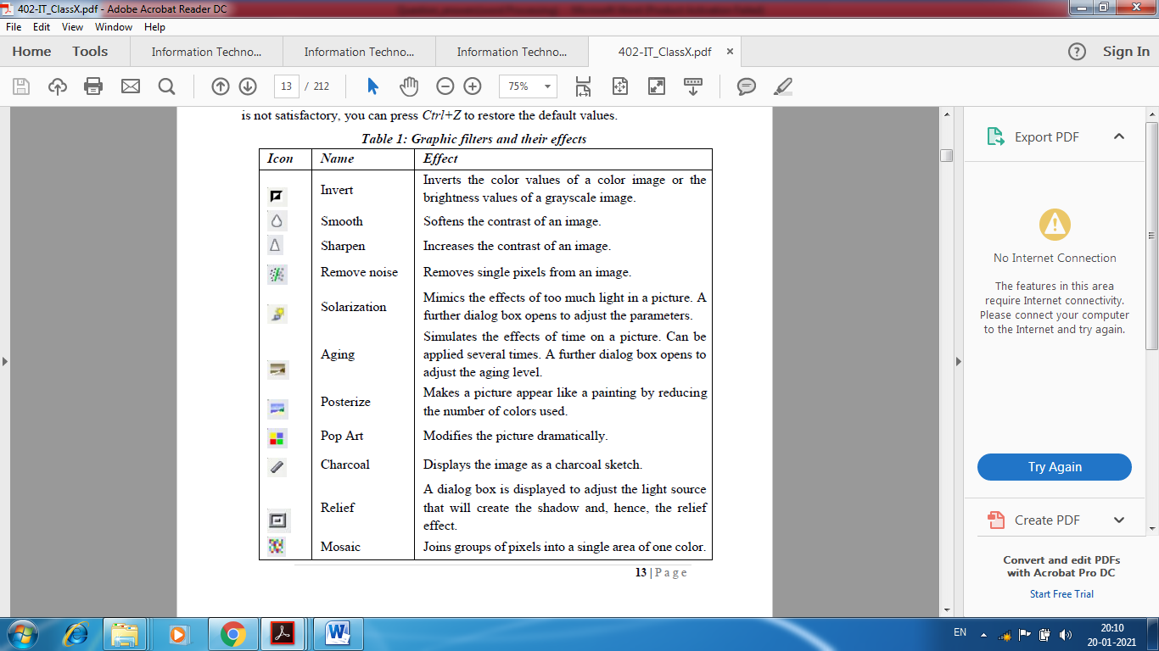

Q. List any three methods of inserting images in a text document.

Ans : When the image is in a file stored on the computer, you can insert it into an Open Office document using either of the following methods:

* **Inserting An Image From The Clipboard**
* **Inserting An Image Using A Scanner**
* **Inserting An Image From The Gallery**
* **Drag and Drop**
* **Insert Picture Dialog**

1. Click in the Open Office document where you want the image to appear.

2. Choose **Insert > Picture > From File from the menu bar.**

Q. What do you understand by the terms:

a. Text Wrapping : Text wrapping refers to the relation of graphics to the surrounding text, which may wrap around the graphic on one or both sides, be overprinted behind or in front of the graphic, or treat the graphic as a separate paragraph or character.

b. Anchoring : Anchoring refers to the reference point for the graphics. This point could be

the page, or frame where the object is, a paragraph, or even a character. An image always

has an anchor point.

Q What are templates? What are the advantages of using templates?

Ans : A template is a predefined layout that contains sample content,themes,colours,font styles, background styles etc and gives an initial foundation to create a document.By using a template , we can quickly create a new document.

Advantages

Templates are very useful for the following reasons

* Templates simplify document creation: Since the formatting features are predefined, templates are easy to apply and at the same time, they increase our efficiency.
* Templates save time and money: Utilizing readymade templates is less time consuming than creating documents from the ground up and hence save time and money.
* Offer consistency and clarity: Templates ensure that all documents have a standard layout, look and feel
* Templates are valuable for types of documents that are used frequently such as weekly presentations, application forms, reports etc.

Q What is the difference between styles and templates?

Ans: Styles keep your formatting consistent within a document. Templates allow you to re-use text, and keep your look and feel consistent across multiple documents.

**Word styles** provide a quick way to change the overall color and fonts. If you want to change text formatting quickly, Word styles are the most effective tools. After you apply a style to different sections of text in your document, you can change the formatting of this text simply by changing the style.

Templates are files that help you design interesting, compelling, and professional-looking documents. They contain content and design elements that you can use as a starting point when creating a document. All the formatting is complete; you add what you want to them. Examples are resumes, invitations, and newsletters.

Q. Give examples of databases in which the Data Source can be created

Ans : Spreadsheet, Text file, Access

Q .What are the three basic steps of Mail Merge?

Ans : The three basic steps of Mail Merge are:

• Creating Main Document

• Creating Data Source

• Merging Main Document and Data Source

Q Name the types of documents you can make using Mail Merge option.

Ans: Letters, e-mails, envelopes , labels , directories are types of documents you can make using Mail Merge option

Q. Define data source and main document.

Ans : Main Document: This is the document that contains the letter or text which is to be sent. For

example, an invitation.

Data Source: This is the file where the addresses of all the recipients are stored.

**Write T for true or F for false.**

1. Mail Merge is useful when we have to type different letters.

2. Current document opened in Word Processing can be used as the main document.

3. Data source is the document that contains the letter to be merged.

4. Multiple copies of the document cannot be printed.

5. We can edit the individual letters and print them.

Ans : 1. F 2. T 3. F 4. F 5. T

Q. How can we rename a worksheet?

Ans: There are three ways you can rename a worksheet, and the only difference between them is the way in which you start the renaming process. You can do any of the following:

• Double-click on one of the existing worksheet names.

• Right-click on an existing worksheet name, then choose Rename from the resulting Context menu.

• Select the worksheet you want to rename (click on the worksheet tab) and then select the Sheet option from the Format menu. This displays a submenu from which you should select the Rename option.

Q. What are the two ways of referencing cells in other worksheets?

Ans : There are two ways to reference cells in other sheets: by entering the formula directly using the keyboard or by using the mouse

* **Creating The Reference With The Mouse**
* **Creating The Reference With The Keyboard**

Q. Differentiate between relative and absolute hyperlinks.

Ans : An absolute link will stop working only if the target is moved. A relative link will stop working only if the start and target locations change relative to each other. For instance, if you have two spreadsheets in the same folder linked to each other and you move the entire folder to a new location, a relative hyperlink will not break.

Q. How can we add comments to the changes made?

Ans: **To add a comment to a change:**

1. Make the change to the spreadsheet.

2. Select the cell with the change.

3. Choose Edit > Changes > Comments. The dialog shown below appears. The automatically-added comment provided by Calc appears in the title bar of this dialog and cannot be edited.

4. Type your own comment and click OK.

Q. State True/ False

Original author of the Worksheet can accept or reject changes made by other users.

Ans: True

Q. What are Macros?

Ans: A macro is a saved sequence of commands or keystrokes that are stored for later use in a spread sheet software. The OpenOffice.org (OOo) macro language is very flexible, allowing automation of both simple and complex tasks. They are very useful for automating repetitive tasks.

Q. How can we record a Macro?

Q. Fill up the blank

a. Macros are useful to _repeat a task the same way over and over again

Q What does DBMS stands for?

Database Management System

Q.What does RDBMS stands for?

Relational Database Management System

Q. What are **Database Servers**

**Ans:** Database servers are dedicated computers that hold the actual databases and run only the DBMS and related software.

Q Name some popular DBMS ?

Ans: Well known DBMSs include Oracle, IBM DB2, Microsoft SQL Server, Microsoft Access, PostgreSQL, MySQL, FoxPro, and SQLite.

Q Into how many types data can be organised .

Ans : **Data can be organized into two types:**

• **Flat File**: Data is stored in a single table. Usually suitable for less amount of data.

• **Relational**: Data is stored in multiple tables and the tables are linked using a common field. Relational is suitable for medium to large amount of data.

Q. What is a record ?

Ans: A record is a set of information (made up of fields) stored in a database about one of the items.

Q. What are the key features of a database ?

Ans:

1. A database can have one or many tables. An address book example is a very simple one, in real world there are many more details involved. A big company would have in its database, one table for its products, one table for its suppliers, one table for its customer details, one for orders received and maybe many others.

2. Each table in a database contains information about one type of item. So, a database is *a container that holds tables and other objects and manages how they can be used.*

3. Another very important thing to remember is that when we put in information, we may have people with the same name (there can be more than one Charu Arora) or the same address (members of a family). But when creating a database an important feature is **record uniqueness** in every table. it is important to be able to distinguish between different items having duplicate values.

Uniqueness helps to avoid accidental duplication of records caused by user or computer error. This can be achieved by using some number or value that uniquely identifies a record. If such a unique value does not exist in your fields, as the database designer, you can create a special additional field in a table where unique numbers or values can be assigned for each new entry. Therefore, every table has a key field which ensures that there are 100% unique values throughout the database.

4. Every database table should have one or more fields designated as key. You can assign a unique value to this key for differentiating records that may have similar names or addresses.

[What is the role of online transaction in e-shopping and e-ticketing??](https://mycbseguide.com/questions/845197/)

Online transaction is very useful in our daily life. It's very helpful when notes are changed. It is helpful for online shopping. It is used to buy tickets online like movie tickets, rail tickets,bus tickets,etc.

Online transaction is much easier than going offline.. Tickets can be brought easily.. We can also do shopping from online sites like Amazon, Flipkart, OLX. etc..

Practice Questions

Q How can we create our own styles ?

Q What are advantages of Mail Merge ?

Q. Explain Image Cropping ?

Q. List the procedure involved in Linking HTML Tables to Calc Worksheet

**QUESTIONS: (TABLE OF CONTENTS)**

1. Create table of contents for your project.

2. Create a document in Word on a topic of your choice of minimum 10 pages.

Format the document with various fonts (minimum 12, maximum 15) and margins (minimum 2, maximum 4).

The document should include

a) A bulleted or numbered list

b) A table containing relevant details

c) A picture of lion using clip art gallery

d) An example of word art

e) A header with student name & date

f) A footer with pagination Create a table of contents for this document.

5. Fill up the blanks

a. At the bottom of each worksheet window is a small tab that indicates the ____________ of the

worksheets in the workbook.

b. A ___________ refers to a cell or a range of cells on a worksheet and can be used to find the

values or data that you want formula to calculate.

c. Spreadsheet software allows the user to share the workbook and place it in the ____________

location where several users can access.

d. Spreadsheet software can find the changes by __________ Sheets.